10 – ReactJS-HOL
Page Header Elements & Source Object Definition
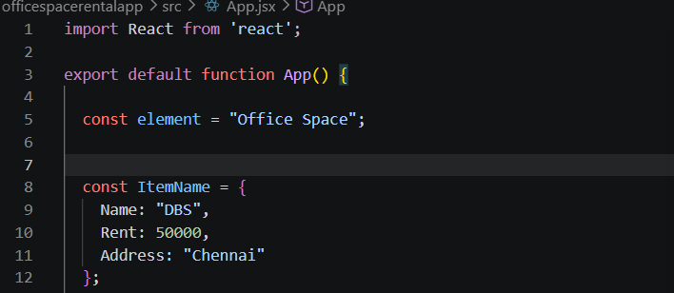
Conditional Styling Logic Block Evaluation
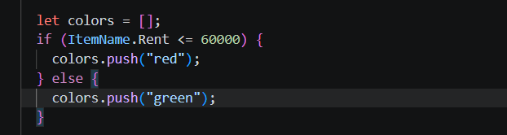
Display Structure Rendering (JSX Node Architecture)
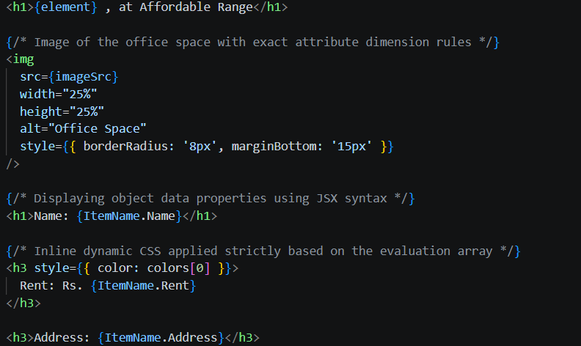
Code Output:
